Report 4 – 18.04.2016

**Impedance model of WT converter and HVDC converter.**

I have implemented models of frequency dependent impedances for converters, till now for case with only one WT rated as all sources of wind farm (400MW). The resulting positive and negative impedances of both converters are as follows:

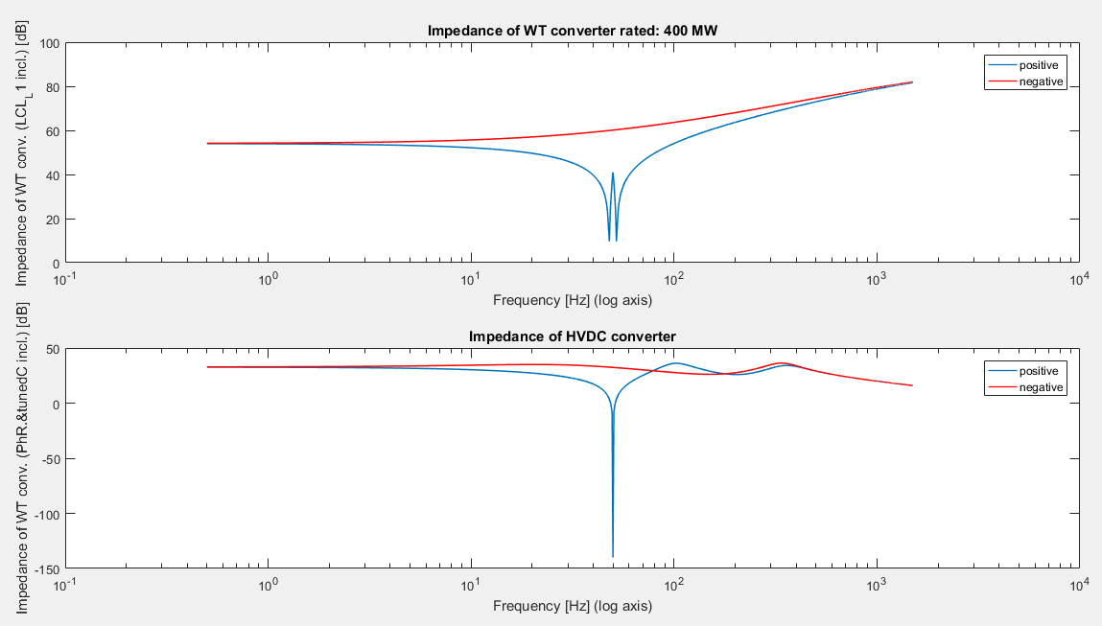

It seems like the models are fine (comparing to paper I am studing), since they have similar convexities and extreme points etc. However the challenge appears of adjusting the values of PI regulators for Current/Voltage Control Compensator and PLL Compensator in my particular case.

With these impedance models included in the resonance of frequency sweep and HMA looks like below (blue lines – model without impedance models (with voltage sources instead) and orange lines – model with frequency dependent converters):

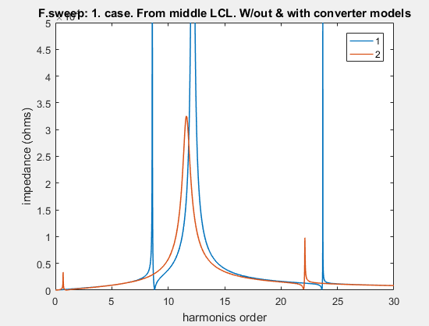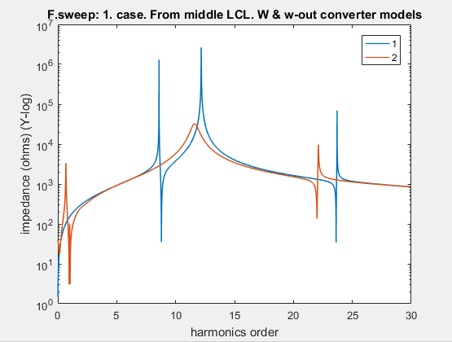

HMA analysis below. Bottom graphs are for models with impedances of converters included.

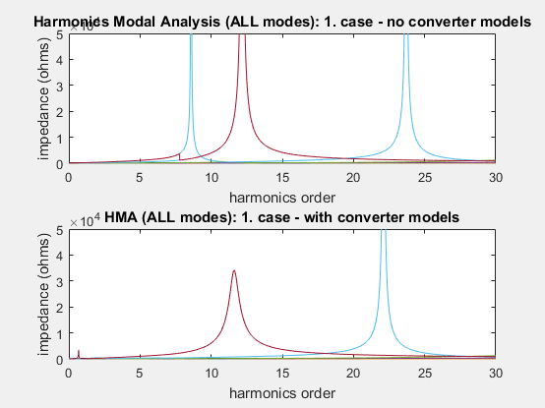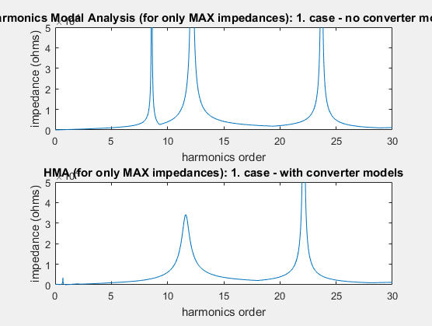

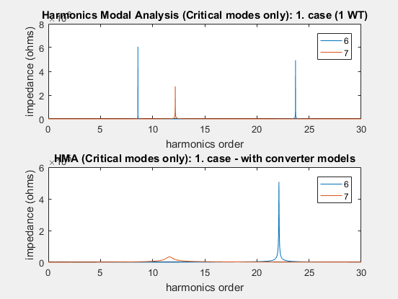

Both methods converge very nicely to each other and as you can see the difference between “without and with” converter models is quite significant – e.g. one harmonics is removed. Again, the control parameters of the converter models should be somehow adjusted.

When it comes to stability based on Nyquist criterion I have some questions and would be grateful for discussion (eg via Hangout). But let me present you what I am wondering. The main problem is that in the models presented in the papers, for stability study on the basis of Nyquist Stability Criterion, they use simple model like:



where Zw is WT converter impedance, Zr is HVDC converter impedance and Zc is the impedance of the grid between them.

Now, the problem is that in calculations they present that there is only one cable between converters and this cable is modelled by only series elements which aggregated give Zc.

In my grid, between converters, there are more elements: LCL filter, 3 transformers, 2 cables and they include also shunt capacitances. In this situation, I believe that I can either use only series R’s and L’s of those elements (shunt capacitances neglected) or try to model them in the other way.

I am thinking about modelling elements (for Nyquist stability only) as two-port elements each and then aggregated into one single two-port element (for example as $π$ or $T$ model). By two-port elements I mean element like:

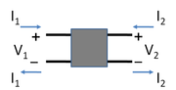

Then, each element can be easily aggregated with neighbour using ABCD (chain) parameters:

 \begin{bmatrix} V_1 \\ I_1 \end{bmatrix} = \begin{bmatrix} A & B \\ C & D \end{bmatrix} \begin{bmatrix} V_2 \\ -I_2 \end{bmatrix} 

After single element is obtained, ABCD can be converted to impedance parameters z11, z12, z21, z22:

 \begin{bmatrix} V_1 \\ V_2 \end{bmatrix} = \begin{bmatrix} z_{11} & z_{12} \\ z_{21} & z_{22} \end{bmatrix} \begin{bmatrix} I_1 \\ I_2 \end{bmatrix} 

and two-port model of element can be collapsed into a one port model providing that there is impedance of “load” or “source” connected to one of the side of the element. That “load” and ”source” impedance can be impedance using one of converter impedance modelled above. That makes two approaches of the impedances - input and output impedances:

Z_\text{in} = Z_{11} - \frac{Z_{12}Z_{21}}{Z_{22}+Z_L}

Z_\text{out} = Z_{22} - \frac{Z_{12}Z_{21}}{Z_{11}+Z_S}

where ZL would be impedance of “load” – HVDC converter, ZS of the “source” – WT converter.

Than Nyquist stability criterion would be computed:



where Zc is either Zin or Zout.

**Does this idea of modelling elements between the converters makes sense in your opinion?**

Actually, I have already tried to model it in this way, manipulating with transfer functions of elements and plotting Nyquist at the end.

First, transfer functions of impedance models of converters has between 5 and 7 zeros or poles.

Then, transfer function of the system, including converter models and the rest of elements (with shunt elements neglected) has 13 zeros and 13 poles, thus the Nyquist plots are already sometimes tangled, for example:

0.009915 s^13 + (114-31.15i) s^12 + (1.741e05-3.236e05i) s^11 + (4.857e08-5.697e08i) s^10

- (2.679e10+2.162e12i) s^9 - (2.275e15+1.344e15i) s^8 - (1.882e18-6.352e17i) s^7

- (6.066e20-1.255e21i) s^6 + (4.763e23+6.737e23i) s^5 + (3.129e26-1.02e26i) s^4

- (9.511e27+8.393e28i) s^3 - (1.351e31+5.265e29i) s^2 - (1.977e32-1.218e33i) s

+ (4.751e34+1.28e34i)

-----------------------------------------------------------------------------------------------------

s^13 + (1.787e04-3335i) s^12 + (2.269e07-5.491e07i) s^11 + (1.485e10-7.65e10i) s^10 - (6.136e13

+2.037e14i) s^9 - (3e17+3.302e16i) s^8 - (9.367e19-2.199e20i) s^7 + (9.291e22+7.708e22i) s^6

+ (3.554e25-2.185e25i) s^5 - (1.752e27+1.024e28i) s^4 - (1.876e30+4.708e29i) s^3

- (1.548e32-2.098e32i) s^2 + (1.281e34+1.809e34i) s + (8.053e35-3.118e35i)

With implementation of the impedances like I described above (Zin or Zout) transfer function of whole system reaches up to 49 zeros and 49 poles…

Below, Nyquist plots of systems: 1) with shunt elements neglected (only R’s and L’s included in Zc impedance),   
2) with Zin impedance equals Zc 3) with Zout impedance equals Zc.

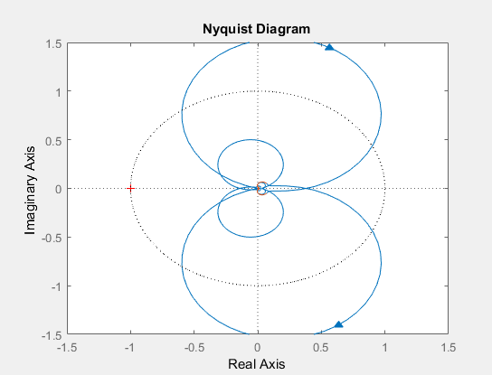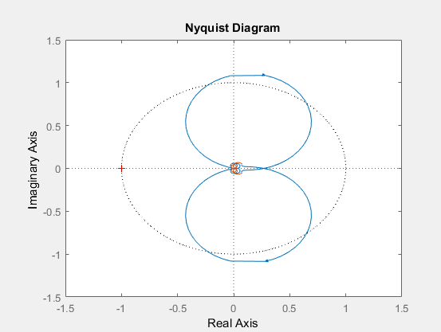

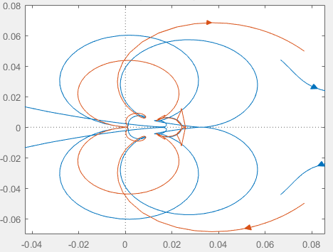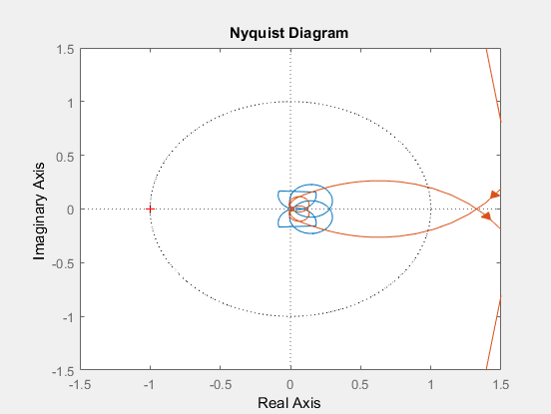

(49 zeros and poles)

There is also something that I have obtained from Nyquist plots that makes more sense. In the graphs, you can see dashed circle of radius = 1. When the Nyquist plot crosses that circle, the frequency at that moment can be found and this frequency corresponds very accurately to first (lowest) harmonic resonance (obtained from frequency sweep or HMA). Similar observations I found in one publication. They do not mention anything about higher resonances.



However, in my case, harmonic order is very low (below fundamental). (But again, parameters for converters control are quite random, not adjusted).

From f.sweep: 0.690000

From HMA: 0.690000

From Nyquist: 0.68497

Very similar values you can obtain for the Nyquist analysis, with implementation of Zin instead of neglecting capacitances (second Nyquist plot, previous page):

From Nyquist: 0.69519

This approach looks more accurate that the opposite one (with Z out).